13th Japan-Korea Laparoscopic Gastrectomy Joint Seminar

Date
February 10, Saturday, 2018
Beppu, Oita.

Tentative Schedule
(19:00-)
(8:30-17:00)
(18:30-)
Welcome Dinner
Seminar
Reception
Feb. 9 (Friday)
Feb. 10 (Saturday)

Seminar Venue & Hotel Information
Beppuwan Royal Hotel
Hijimachi, Hayami-gun, Oita larger section of a village flat way character inlet 1825
http://www.daiwaresort.co.jp
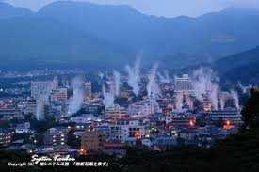


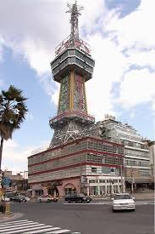



Transportation Information
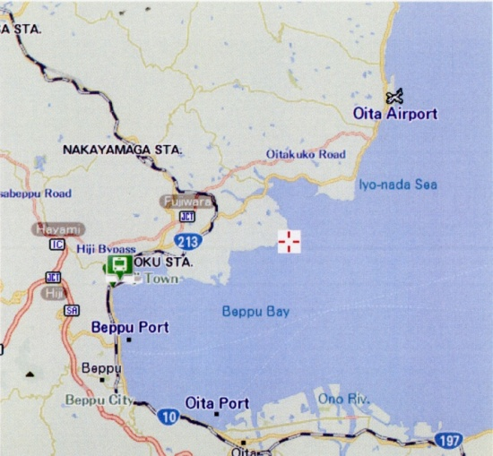

Beppuwan Royal Hotel

Fukuoka Airport
・by Bus Express Bus [Toyonokuni]. 120min
※Departure from Hakata Station
・by Train JR Nippo Main Line (Limited Express). 150min

Oita Airport
・by Bus AirPort Special Express Bus Airliner. 30min

